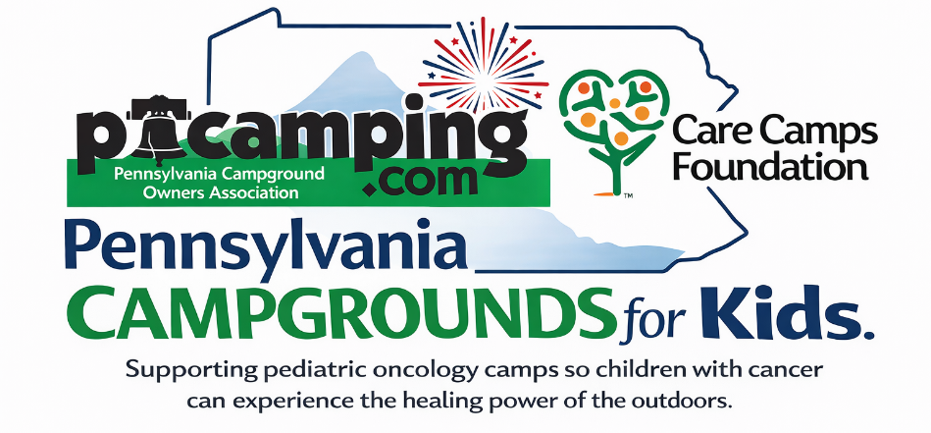

SOCIAL MEDIA POSTING EXAMPLES

POST 1
We are proud to be part of the Pennsylvania Campgrounds for Kids campaign this September!
We are competing with campgrounds across the state to raise funds that help make camp experiences for children with cancer possible. These are safe and accessible, medically supervised experiences filled with joy, belonging, and the healing power of the outdoors, all at no cost to families.
Help us climb the leaderboard and make a real impact. Donate today and support our campground’s goal. Every gift matters.
https://secure.everyaction.com/o6yryQ2iHU-TsxjHIf0qsA2

POST 2
We are officially in the race!
All September long, we are competing against other Pennsylvania campgrounds to see who can raise the most support for children with cancer.
When you give through our page, you are helping create moments of outdoor fun, connection, and relief for families who need it most.
Let’s show what our campground community can do. Help us take the lead!
https://secure.everyaction.com/o6yryQ2iHU-TsxjHIf0qsA2

POST 3
Leaderboard update!
We are working hard to move up in the Pennsylvania Campgrounds for Kids campaign, and we need your help.
Your donation supports camp experiences for children with cancer across the United States and Canada, giving them a chance to just be kids in a safe and caring environment.
Let’s keep the momentum going and push for the top spot.
https://secure.everyaction.com/o6yryQ2iHU-TsxjHIf0qsA2

POST 4
A little friendly competition for a big cause
We are going head to head with campgrounds across Pennsylvania this September, all to support children with cancer through the healing power of the outdoors.
We want to win, but more importantly, we want to make a difference.
Join us by making a donation and helping our campground lead the way.
https://secure.everyaction.com/o6yryQ2iHU-TsxjHIf0qsA2

POST 5
Last call to help us win
September is coming to a close, and we are making our final push in the Pennsylvania Campgrounds for Kids campaign.
Every dollar brings us closer to the top and helps provide children with cancer a chance to experience joy, belonging, and time outdoors at camp.
If you have been thinking about giving, now is the time. Help us finish strong.
https://secure.everyaction.com/o6yryQ2iHU-TsxjHIf0qsA2

POST 6
Why we are doing this
We believe every child deserves moments of adventure, outdoor fun, and a place where they feel like they belong.
That is why we are proud to support camp experiences for children with cancer through the Pennsylvania Campgrounds for Kids campaign.
If our campground has made a difference in your life, we invite you to pay it forward and help us make a difference for others.
https://secure.everyaction.com/o6yryQ2iHU-TsxjHIf0qsA2

